**CS673 Software Engineering**

**Team 3 - StockPickers**

**Manual test Reports**

**Index :**

| **Case** | **Pass/Fail** |
| --- | --- |
| **01** | **Pass** |
| **02** | **Pass** |
| **03** | **Pass** |
| **04** | **Pass** |
| **05** | **Pass** |
| **06** | **Pass** |
| **07** | **Pass** |
| **08** | **Pass** |
| **09** | **Pass** |

## Test ID 01

|  | **Comment** | |
| --- | --- | --- |
| Test ID | 01 | |
| Tester: | Duy Nguyen | |
| Test Description | Test the navigation of the app | |
| Test Items | Navigation | |
| Test Priority | Medium | |
| Dependencies | requirements.txt | |
| Input Data | None | |
| Post Conditions | N/A | |
| Expected Output | All links lead to the correct pages. | |
| **Steps** | **Test Procedure** | **Decision** |
| 1 | Launch back end | Set up. |
| 2 | Launch front end | Set up. |
| 3 | Check home page | Pass |
| 4 | Click on dashboard | Pass |
| 5 | Click on About | Pass |
| ***Final Decision*** | | Pass |

## Test ID 02

|  | **Comment** | |
| --- | --- | --- |
| Test ID | 02 | |
| Tester: | Duy Nguyen | |
| Test Description | Test if App displays graph | |
| Test Items | Test if App displays graph | |
| Test Priority | High | |
| Dependencies | requirements.txt | |
| Input Data | FSR selection/daily grain | |
| Post Conditions |  | |
| Expected Output | Stock data displayed in the form of a line graph | |
| **Steps** | **Test Procedure** | **Decision** |
| 1 | Launch back end | Set up. |
| 2 | Launch front end | Set up. |
| 3 | Click on dashboard | Pass |
| 4 | Select FSR | Pass |
| 5 | Select Daily Grain | Pass |
| 6 | Select “”Get Selected Stock Data” | Pass |
| 7 | Graph Displayed? | Pass |
| 8 | Grain = Daily? | Pass |
| ***Final Decision*** | | Pass |

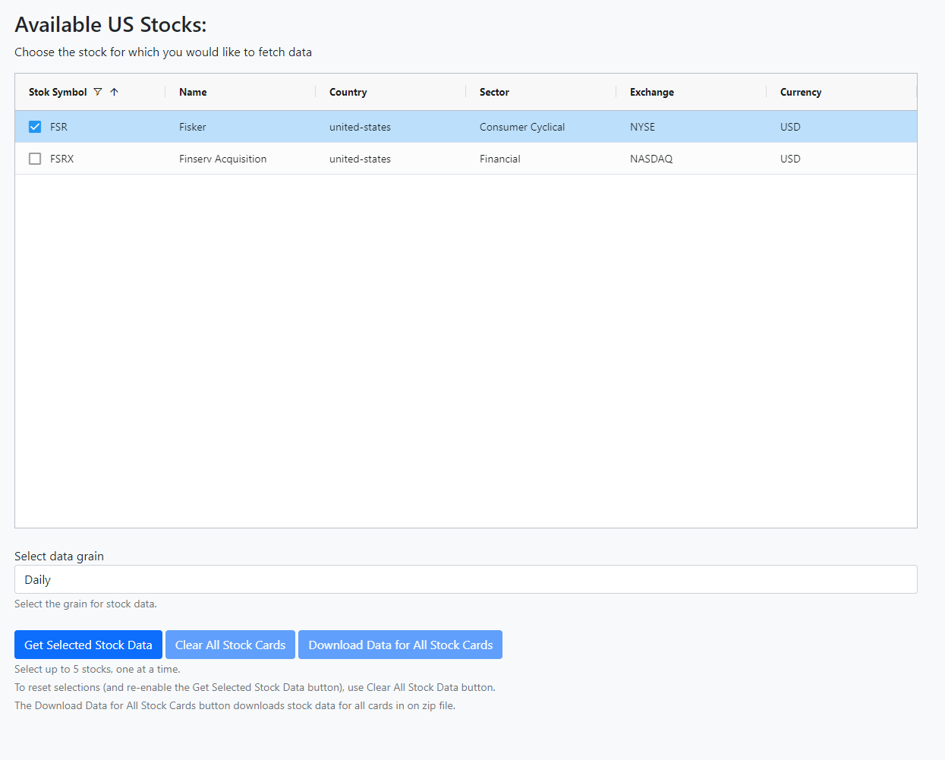

Test02-Fig1

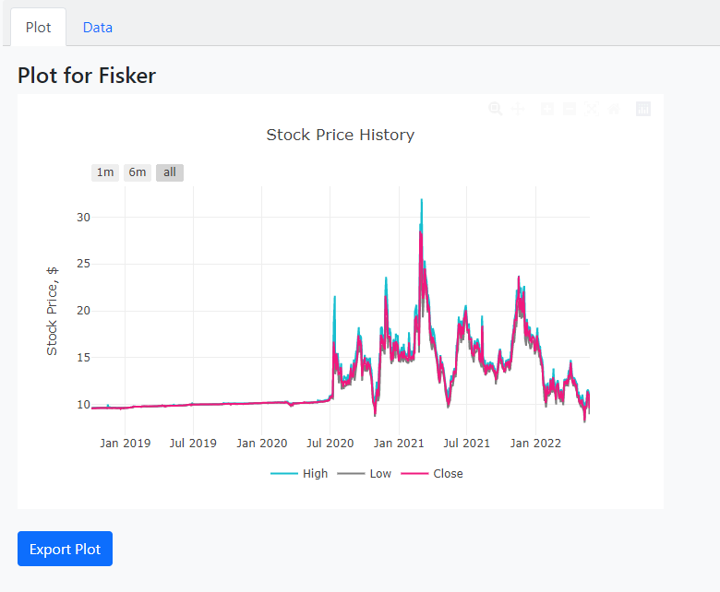

Test02-Fig2

## Test ID 03

|  | **Comment** | **Decision** |
| --- | --- | --- |
| Test ID | 03 |  |
| Tester: | Jing Tian |  |
| Test Description | Test if App displays all stocks correctly |  |
| Test Items | Test if App displays stocks correctly |  |
| Test Priority | High |  |
| Dependencies | requirements.txt |  |
| Input Data | N/A |  |
| Post Conditions | N/A |  |
| Expected Output | All stock will display in alphabetical order, and with correct information. |  |
| **Steps** | **Test Procedure** | **Decision** |
| 1 | Launch back end | Set up. |
| 2 | Launch front end | Set up. |
| 3 | Click on launch app | Pass |
| 4 | Wait till every stocks loads | Pass |
| 5 | Check if there’s any stock missing or displayed incorrectly | Pass |
| ***Final Decision*** | | Pass |

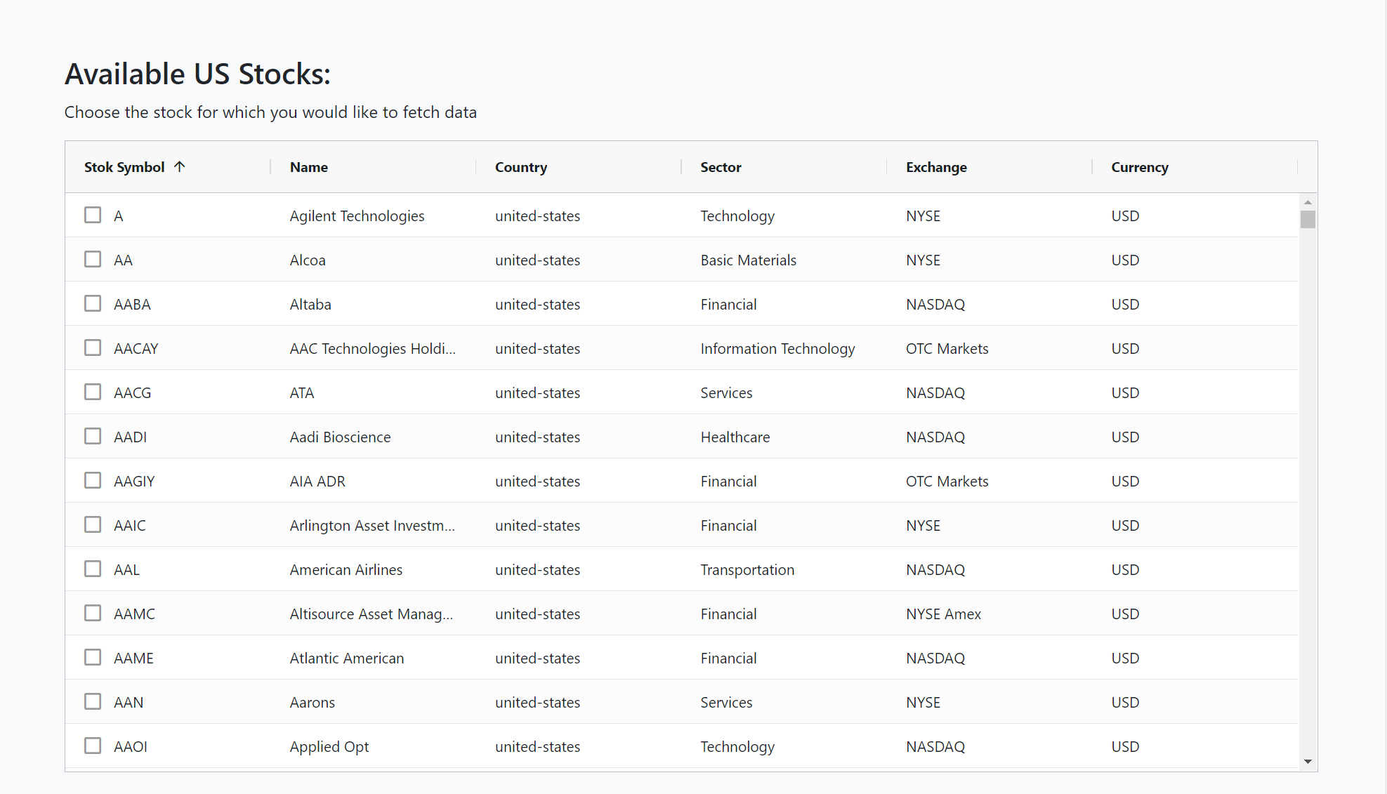

Test03-Fig3

## 

## Test ID 04

|  | **Comment** | **Decision** |
| --- | --- | --- |
| Test ID | 04 |  |
| Tester: | Jing Tian |  |
| Test Description | Test if App fetched correct data |  |
| Test Items | Test if App fetched correct data |  |
| Test Priority | High |  |
| Dependencies | requirements.txt |  |
| Input Data | N/A |  |
| Post Conditions | N/A |  |
| Expected Output | The graph and fetched data should be consistent |  |
| **Steps** | **Test Procedure** | **Decision** |
| 1 | Launch back end | Set up. |
| 2 | Launch front end | Set up. |
| 3 | Click on launch app | Pass |
| 4 | Choose one stock from the stock list. | Pass |
| 5 | Display graph of that stock | Pass |
| 6 | Display data of that stock | Pass |
| 7 | Examine if graph and related data are consistent | Pass |
| ***Final Decision*** | | Pass |

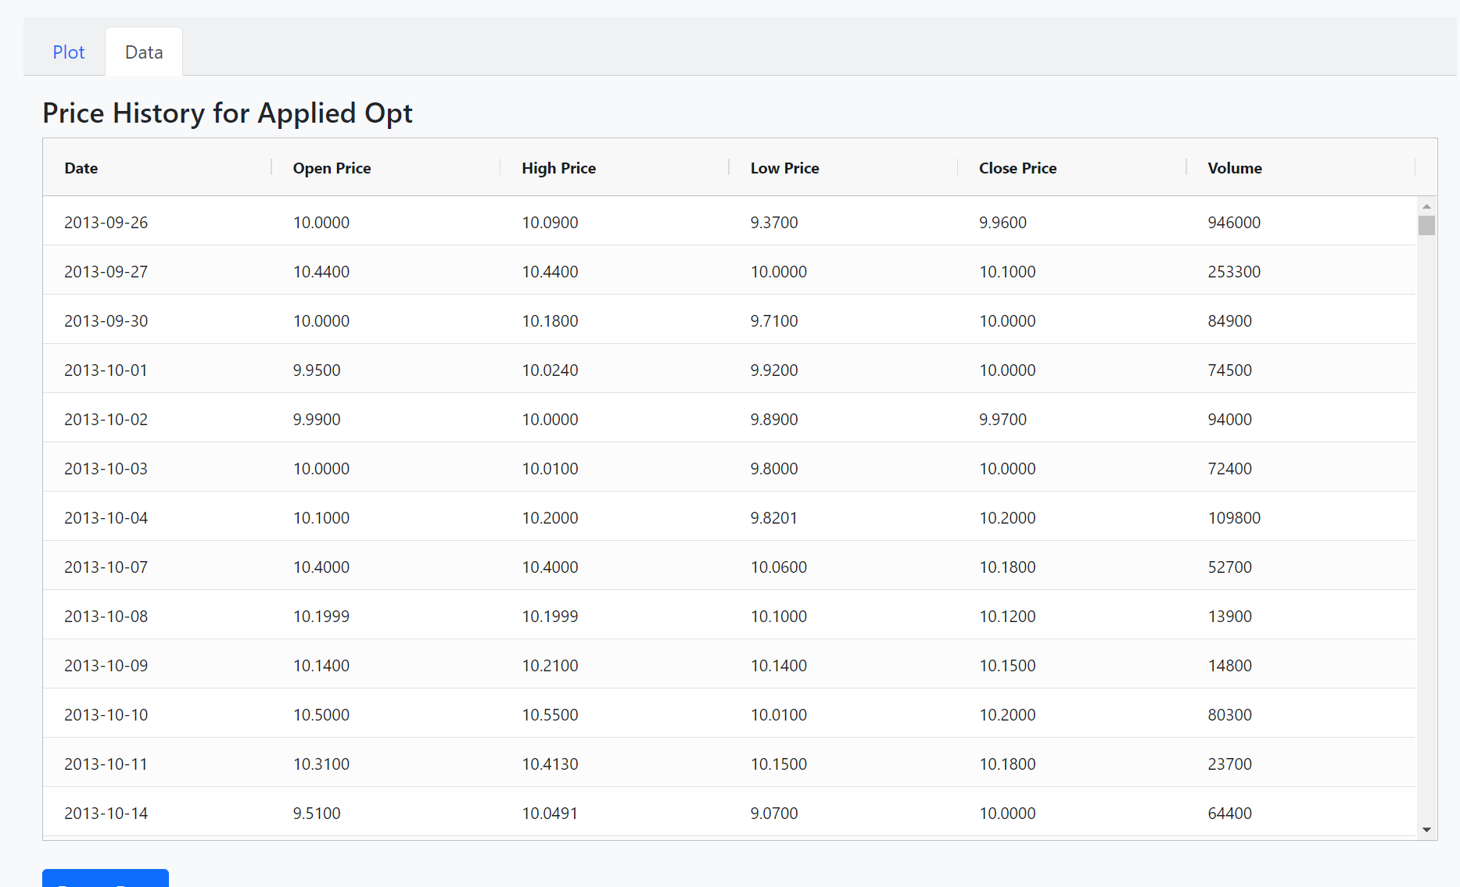

Test04-Fig4

## Test ID 05

|  | **Comment** | **Decision** |
| --- | --- | --- |
| Test ID | 05 |  |
| Tester: | Jing Tian |  |
| Test Description | Test if forecast feature works properly |  |
| Test Items | Test if forecast feature works properly |  |
| Test Priority | High |  |
| Dependencies | Requirements.txt |  |
| Input Data | N/A |  |
| Post Conditions | N/A |  |
| Expected Output | The forecast feature should correctly generate forecast for selected stock |  |
| **Steps** | **Test Procedure** | **Decision** |
| 1 | Launch back end | Set up. |
| 2 | Launch front end | Set up. |
| 3 | Click on launch app | Pass |
| 4 | Choose one stock from the stock list. | Pass |
| 5 | Check the “generate forecast” box under table | Pass |
| 6 | Click “get selected stock data” | Pass |
| 7 | Display graph of that stock with forecast | Pass |
| 8 | Display data of that stock | Pass |
| 9 | Examine if forecast are working correctly | Pass |
| ***Final Decision*** | | Pass |

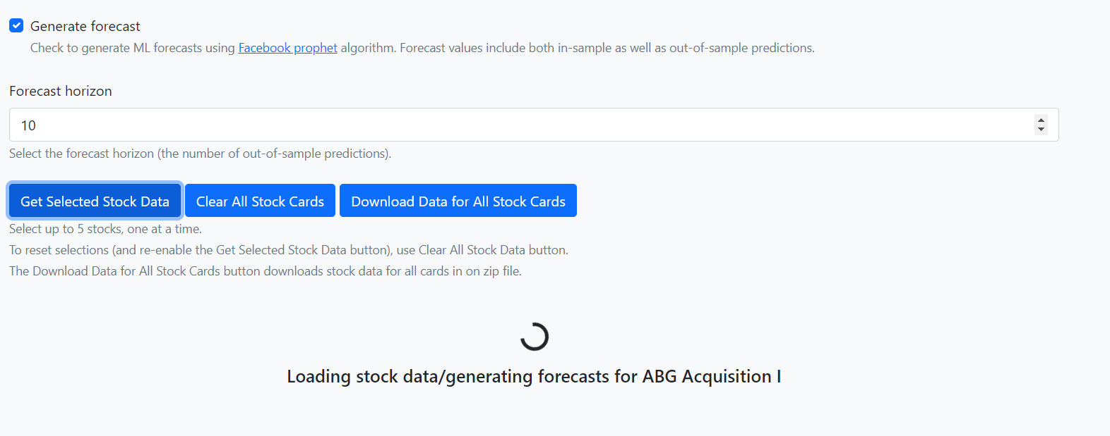

Test05-Fig5

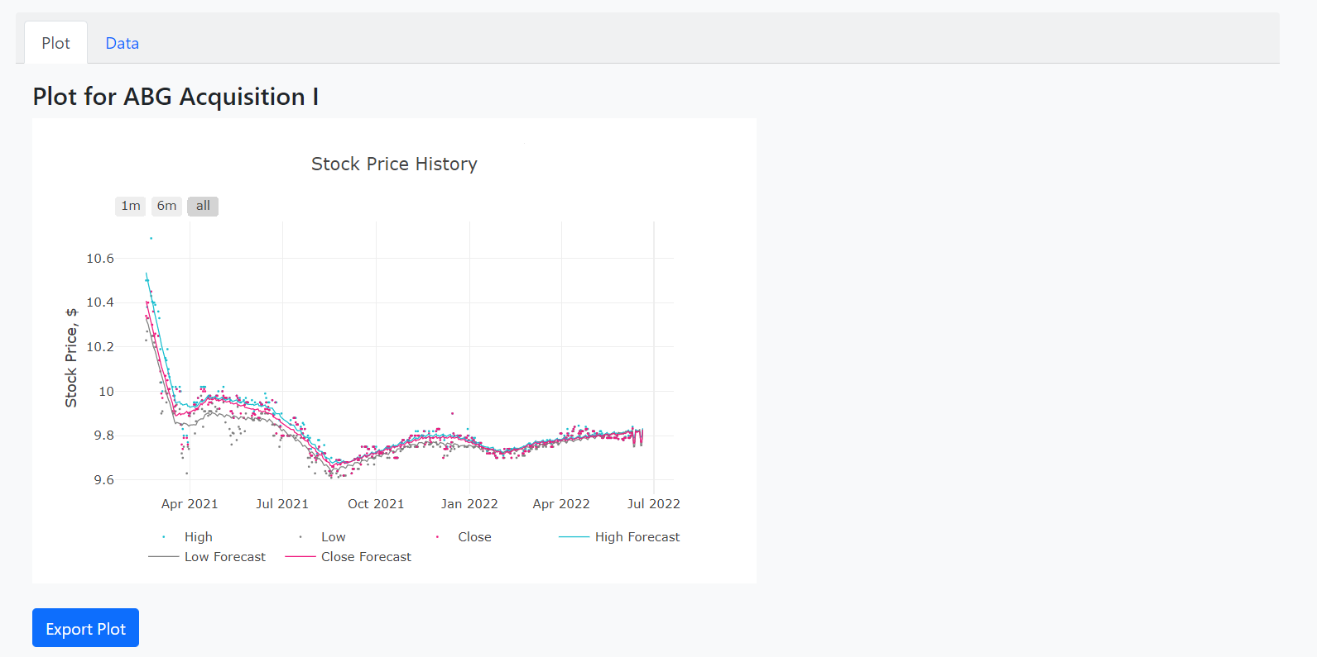

Test05-Fig6

## Test ID 06

|  | **Comment** | **Decision** |
| --- | --- | --- |
| Test ID | 06 |  |
| Tester: | Jing Tian |  |
| Test Description | Test if “add stock as favorite” feature works properly |  |
| Test Items | Test if “add stock as favorite” feature works properly |  |
| Test Priority | Midean |  |
| Dependencies | Requirements.txt |  |
| Input Data | N/A |  |
| Post Conditions | N/A |  |
| Expected Output | When user clicks the star near the stock the star should change color and save user’s choices till next launch |  |
| **Steps** | **Test Procedure** | **Decision** |
| 1 | Launch back end | Set up. |
| 2 | Launch front end | Set up. |
| 3 | Click on launch app | Pass |
| 4 | Choose one stock from the stock list. | Pass |
| 5 | Click the star figure near the stock name | Pass |
| 6 | The blank star (☆) changed to a full star (★) | Pass |
| 7 | Close the app and restart | Pass |
| 8 | Click on launch app | Pass |
| 9 | All favorite stocks should still have full stars (★) near their name instead of blank stars (☆) | Pass |
| ***Final Decision*** | | Pass |

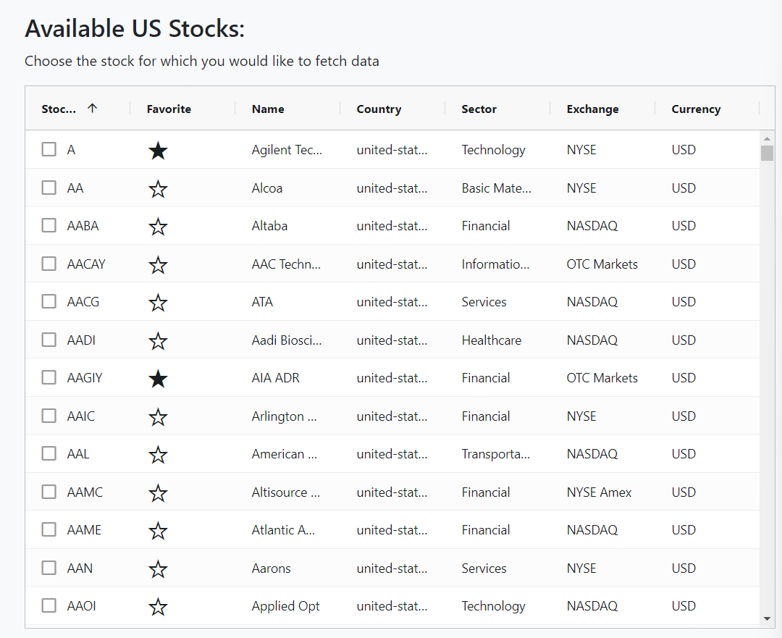

Test06-Fig7

## Test ID 07

|  | **Comment** | **Decision** |
| --- | --- | --- |
| Test ID | 07 |  |
| Tester: | Duy Nguyen |  |
| Test Description | Test Card.JS methods |  |
| Test Items | Methods of Card.js |  |
| Test Priority | Medium |  |
| Dependencies | Requirements.txt, fs,happy-dom,path,vitest |  |
| Input Data | None |  |
| Post Conditions | N/A |  |
| Expected Output | All 5 unit tests for Card JS will pass ( makeCardVisible, setCardTitle,makeSpinnerVisible,  makeSpinnerInvisible,unsetStockCard) |  |
| **Steps** | **Test Procedure** | **Decision** |
| 1 | Launch project | Set up. |
| 2 | Install dependencies | Set up. |
| 3 | Within navigate to stock_getter > frontend_stockgetter>scripts | Set up |
| 4 | Type in npm tests | Set up |
| 5 | Review result | Pass |
| ***Final Decision*** | | Pass |

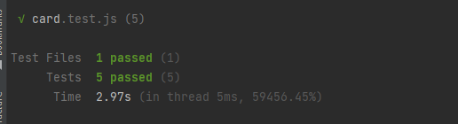

Test07-Fig8

## Test ID 08

|  | **Comment** | |
| --- | --- | --- |
| Test ID | 08 | |
| Tester: | Duy Nguyen | |
| Test Description | Backend views, urls | |
| Test Items | Methods of urls and views | |
| Test Priority | High | |
| Dependencies | Requirements.txt, TestCase,urls,parameterized | |
| Input Data | None(predetermined) | |
| Post Conditions | N/A | |
| Expected Output | All 6 tests are successful | |
| **Steps** | **Test Procedure** | **Decision** |
| 1 | Launch project | Set up. |
| 2 | Install dependencies | Set up. |
| 3 | Within navigate to stock_getter > backend_stockgetter | Set up |
| 4 | Run in virtual environment:python manage.py test stock_service.tests | Set up |
| 5 | Review result | Pass |
| ***Final Decision*** | | Pass |

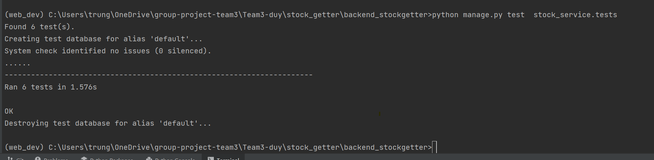

Test08-Fig9

## Test ID 09

|  | **Comment** | **Decision** |
| --- | --- | --- |
| Test ID | 09 |  |
| Tester: | Serguei Chervachidze |  |
| Test Description | Forecaster and ProphetModel interface methods (these 2 classes implement forecasting on backend) |  |
| Test Items | Forecasting and data processing methods |  |
| Test Priority | High |  |
| Dependencies | Requirements.txt, TestCase,test data json files |  |
| Input Data | JSON file with AAPL stock data |  |
| Post Conditions | N/A |  |
| Expected Output | All 3 tests are successful |  |
| **Steps** | **Test Procedure** | **Decision** |
| 1 | Launch project | Set up. |
| 2 | Install dependencies | Set up. |
| 3 | Within navigate to stock_getter > backend_stockgetter | Set up |
| 4 | Run in virtual environment:python manage.py test individual unit tests | Set up |
| 5 | Review result | Pass |
| ***Final Decision*** | | Pass |

